DR.AMBEDKAR COLLEGE, DEEKSHABHOOMI, NAGPUR
DEPARTMENT OF LAW
ACADEMIC SESSION 2023-24
SMCA INSTALLATION CEREMONY

NAME OF THE PROGRAMME: SMCA INSTALLATION CEREMONY
DATE AND DAY: 13th January 2024- Saturday
TIME: 11 AM
VENUE: Auditorium, Dr.Ambedkar College,
Deekshabhumi.
PROGRAMME SUPERVISOR: Dr.Varsha Deshpande
PROGRAMME CO-COORDINATORS: Dr.Vaishali A. Sukhdeve and Ms. Sarika Kamdi

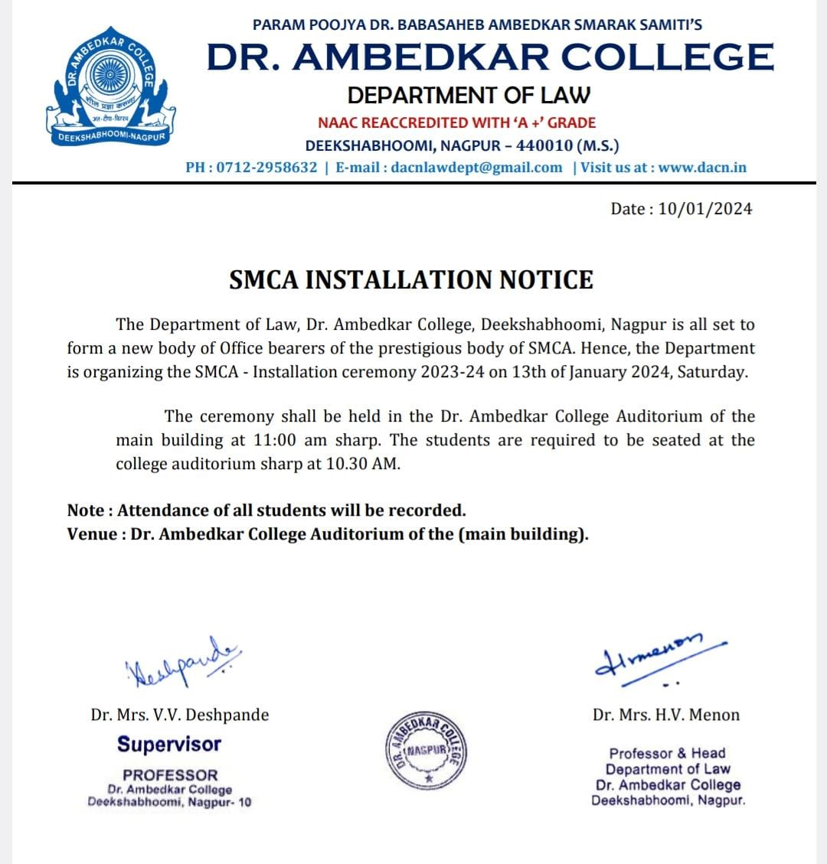

A new team of office bearers of the Student’s Moot Court Association (SMCA) for the academic year 2023-2024 of Dr. Ambedkar College Nagpur was inducted on 13th January 2024. We had on the dias our esteemed Chief guest Adv. Atul Pande, President, High Court Bar Association, Nagpur , Principal Dr. Mrs.B.A Mehre, Head of the department of law Dr.H.V.Menon, the Supervisor of SMCA Dr.V.V.Deshpande, Outgoing President Adv. Unnati Bobde, Outgoing Secretary, Adv. Mugdha Mundle, Incoming President Mrs. Ketki Marpakwar and Incoming Secretary Ms. Anjali Tamshettiwar. The ceremony began with a traditional offering of devotion to Lord Gautam Buddha and Dr. Babasaheb Ambedkar with garlanding of their portraits and lighting the candles by the chief guests and the dignitaries present on the dais.
Further, the chief guest of the ceremony Adv. Atul Pande was offered an eco-friendly welcome with a sapling by the incoming Vice President Ms. Divya Toksiya. The Principal Dr. Mrs.B.A Mehre was welcomed with a sapling by the incoming Treasurer Mr. Aditya Kukadkar.

The Head of the Department of Law Prof. Dr. H. V. Menon then addressed the audience and welcomed the chief guest. Her speech made an enthusiastic start to the ceremony. She encouraged the students to actively participate in the activities conducted by SMCA and also wished all the good luck to the new body of SMCA.

The Supervisor of SMCA, Dr.V.V.Deshpande then presented the introductory remarks. She introduced to the audience the aims and objectives of the SMCA. She clearly pronounced the workings of the body of SMCA and its importance for the development of students. Through her words, she firmly made the students believe that not only the SMCA conducts events, but also develops the qualities of team work, discipline, perseverance and punctuality.

Thereafter, the formal installation of the new team of office bearers took place. Mrs. Ketki Marpakwar was pinned as the President of the SMCA by the chief guest. Incoming president Mrs Ketki Marpakwar then exchanged the chair with the outgoing President Adv. Unnati Bobde. The entire team of SMCA was then installed by the President. Ms. Anjali Tamshettiwar took charge as the Secretary of the SMCA and then exchanged the chair with the outgoing Secretary Adv. Mugdha Mundle. A total of 9 Core-Committee members and 25 Executive Committee members were installed.

The core committee consists of :
PRESIDENT - Ketki Marpakwar
VICE PRESIDENT - Divya Toksiya
SECRETARY - Anjali Tamshettiwar
JOINT SECRETARY- Kuldeep Patil
TREASURER- Aditya Kukadkar
DIRECTOR I- MOOT COURT WORKSHOP - Akshay Wankhede
DIRECTOR II- MOOT COURT COMPETITION – Chaitanya Ranadive
STUDENT COORDINATOR MOOT COURT WORKSHOP- Prerna Wandre
STUDENT COORDINATOR MOOT COURT COMPETITION - Mitali Verma

The executive committee members are:
Ms. Shatakshi Dorle, Ms. Vrushali Dharamshahare, Ms. Prajakta Mahajan, Ms. Vaijayanti Mendhe, Ms. Snehal Wasnik, Mr. Raju Patil, Ms. Roziya Siddiqui, Mr. Sarwesh Kumar, Mr. Tathagat Thakur, Mr. Sahil Bhansali, Mr. Shardul Polke, Ms. Sanika Duragkar, Ms. Stuti Salodkar, Ms. Sumaiyya Chaus, Mr. Himanshu Marodia, Mr. Bhavya Agrawal, Mr. Sanket Gattani, Ms. Maithili Shende, Mr. Hrudyanshu Meshram, Mr. Anirudh Singh, Mr. Ritik Kawale, Ms. Falguni Gupta, Ms. Radhika Khanke, Ms. Deewyani Thakre, Mrs. Hemanta Chahande.

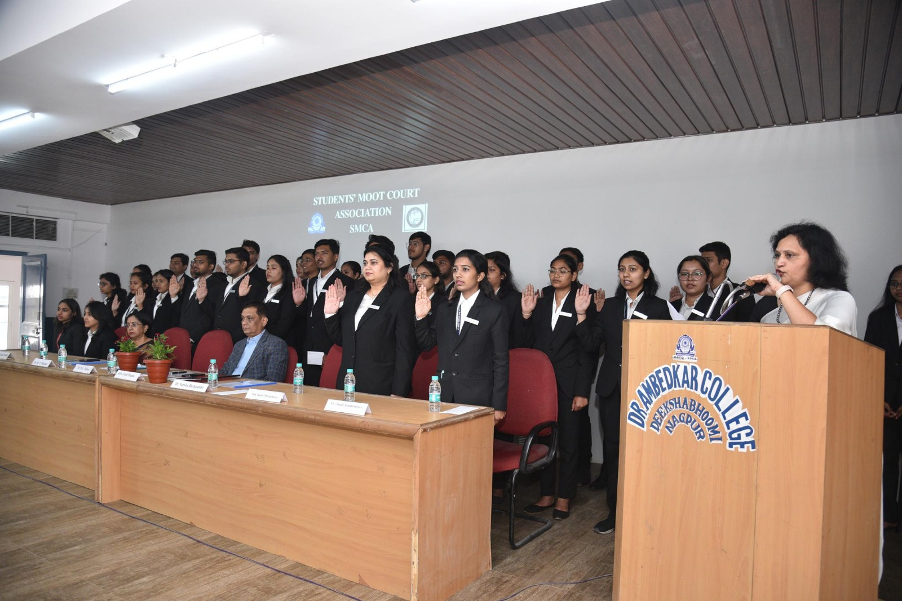
The new office bearers of SMCA then sworn the oath. The oath was administered to the new body of SMCA by the Supervisor SMCA Dr. Varsha Deshpande, followed by the group photograph of the newly elected body of SMCA.

The President, Mrs. Ketki Marpakwar then delivered an impressive acceptance speech which was a fine amalgamation of both, gratitude and confidence.

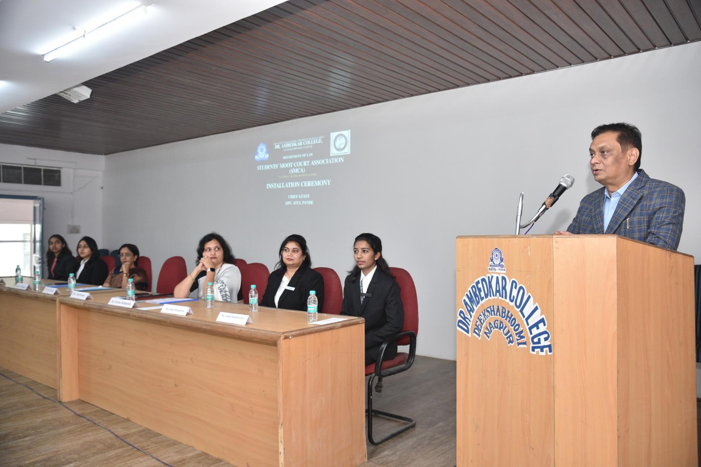
The esteemed Chief Guest Adv. Atul Pande, the President of High Court Bar Association Nagpur, addressed the audience. He shared valuable insights with the Students. His words of motivation will act as a directive for students. Adv. Atul Pande has been working as a lawyer since 1992 having an enriched experience of more than 30 years in legal profession.

The Joint Secretary, SMCA, Mr. Kuldeep Patil presented the Chief guest, Adv. Atul Pande with a memento.

The vote of thanks was delivered by Secretary Ms. Anjali Tamshettiwar. She whole heartedly, extended her sincere thanks to everyone present in the auditorium. The programme was concluded with the singing of the National Anthem. The proceedings of the SMCA Installation ceremony 2022-23 were carried on by Ms. Bushra Khan and Mr. Sahil Bhansali. All faculty members of the Department and students of LLB 3 years and 5 years were present in large numbers.

